DPR APPRAISAL AUTOMATION SYSTEM
Technical Design Document (Cloud Approach)

Table of Content
Executive Summary 3
1. Introduction and Context 4
1.1 Current Appraisal Process 4
1.2 Challenges in Current Process 4
2. Solution 1: POC - Intelligent Query Assistant 5
2.1 Overview 5
2.2 Technical Architecture 5
2.3 Query Processing Workflow (indicative) 6
2.4 Technical Components (Indicative) 6
3. Cloud-Based Production System Architecture 7
3.1 Overview 7
3.2 System Architecture 7
3.3 Multi-Agent Processing Workflow 8
3.4 Agent Specializations (Indicative) 9
3.5 Technical Components and Services 10
3.5.1 AWS-Based Implementation 10
3.5.2 Google Cloud-Based Implementation 10
4. Deployment Architecture and Scalability 11
4.1 High-Availability Design 11
4.2 Scalability Model 11
5. Conclusion 11

Executive Summary
The Department of Expenditure (DoE) currently processes project appraisals through a multi-stage manual review process, involving assessment of project proposals against established guidelines, fiscal norms, and inter-ministerial consultations. This process, while thorough, is time-intensive and requires Subject Officers (SOs) to navigate extensive documentation including General Financial Rules (GFR), Detailed Financial Procedures and Rules (DFPR), Office Memorandums (OMs), and historical appraisal records.
To enhance efficiency and decision-making capability, this document presents a phased automation approach:
Phase 1: Proof of Concept (POC) - Intelligent Query Assistant
The initial phase focuses on creating an AI-powered query assistant leveraging cloud-based AI services with publicly available appraisal guidelines and policy documents. This POC system enables SOs to obtain instant clarifications on appraisal procedures, financial norms, and policy interpretations without processing confidential project documents. The system utilizes a curated knowledge repository of public documents, including GFR, DFPR, standard templates, published OMs, and appraisal/approval guidelines to provide contextual responses to officer queries.
Phase 2: Cloud-Based Production System - Automated DPR Appraisal Platform
The production system implements a cloud-native multi-agent architecture using enterprise AI services (AWS Bedrock or Google Vertex AI) to process confidential DPR documents. This system automates assessment across all appraisal dimensions—need analysis, cost scrutiny, implementation feasibility, and inter-ministerial coordination—while maintaining data security through VPC isolation, encryption, and comprehensive access controls. The cloud deployment provides rapid scaling, managed infrastructure, and consumption-based economics while ensuring regulatory compliance and data residency within designated Indian cloud regions.
Both phases leverage a structured knowledge repository architecture that organizes reference materials into specialized vaults, enabling precise retrieval and context-aware responses. This document provides detailed technical specifications, architecture diagrams, implementation workflows, and deployment considerations for both solutions.

1. Introduction and Context

1.1 Current Appraisal Process
The Department of Expenditure follows a structured appraisal workflow for project proposals:
Figure 1: Current DPR Appraisal Workflow
Ministry prepares Concept Note / DPR
↓
Submission to Department of Expenditure
↓
Preliminary Check by DoE
(Completeness, Format, In-principle Approval)
↓
Multi-Dimensional Appraisal
Need &  Relevance | Outcome &  Performance | Cost & Fiscal  Scrutiny | Implementation  & Risk | Inter-Ministerial  Consultation

1.2 Challenges in Current Process
Challenge | Impact
Information Retrieval | Subject Officers must manually search through extensive documentation (GFR, DFPR, OMs) to locate relevant guidelines
Processing Time | Multi-dimensional assessment across five parameters requires significant time per proposal
Consistency | Varying interpretation of guidelines across different appraisals and officers
Knowledge Management | Historical appraisal decisions and institutional knowledge not systematically captured or accessible

2. Solution 1: POC - Intelligent Query Assistant

2.1 Overview
The Proof of Concept implements an AI-powered query assistant system that enables Subject Officers to obtain instant, contextual responses to appraisal-related queries. The system operates exclusively on publicly available guidelines and policy documents, leveraging managed AI infrastructure.
Characteristic | Details
Scope | Public documents only (GFR, DFPR, published OMs, standard templates)
Use Case | Query resolution on appraisal procedures, financial norms, policy interpretation
Timeline (tentative) | 4-6 weeks for initial deployment

2.2 Technical Architecture
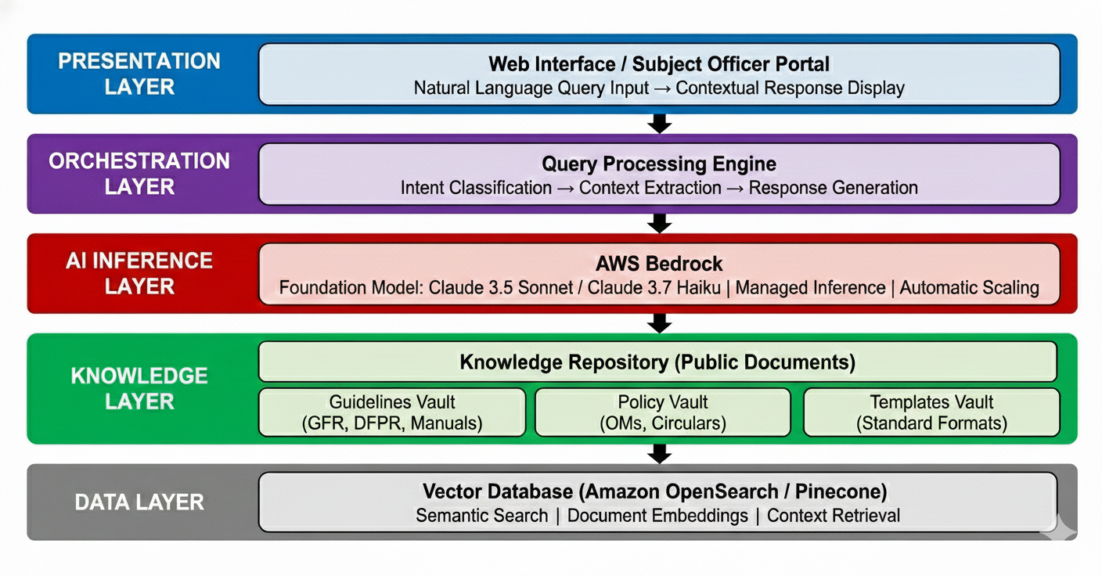
Figure 2: POC System Architecture

2.3 Query Processing Workflow (indicative)

Figure 3: Query Processing Flow
Step 1: Query Input
Subject Officer submits natural language query
Example: "What is the 5.5x rule for cost norms?"
↓
Step 2: Query Understanding
Intent classification → Extract key entities → Generate embedding vector
↓
Step 3: Context Retrieval
Semantic search in vector DB → Retrieve top-K relevant document chunks
↓
Step 4: Response Generation
AWS Bedrock (Claude) generates contextual response with source citations
↓
Step 5: Response Delivery
Formatted answer with references → Display to Subject Officer

2.4 Technical Components (Indicative)
Component | Specification
Foundation Model | Claude 3.5 Sonnet (comprehensive responses) or Claude 3.7 Haiku (quick queries) via AWS Bedrock
Embedding Model | Amazon Titan Embeddings V2 (512-1024 dimensions for semantic search)
Vector Store | Amazon OpenSearch Service with k-NN plugin or Pinecone (managed vector DB)
Orchestration | AWS Lambda (serverless functions) + API Gateway for request routing
Frontend | React.js web application hosted on AWS Amplify or S3+CloudFront
Document Storage | Amazon S3 (public documents repository with versioning)

3. Cloud-Based Production System Architecture

3.1 Overview
The cloud-based production system processes confidential DPR documents through a multi-agent architecture deployed on enterprise cloud infrastructure. The system utilizes managed AI services for inference while implementing comprehensive security controls to protect sensitive data.
Characteristic | Details
Scope | Full DPR processing including confidential project documents and sensitive financial data
Infrastructure | Cloud-native deployment using AWS Bedrock or Google Vertex AI managed services
Security Model | VPC isolation, encrypted storage, private endpoints, IAM access control, comprehensive audit logging
Processing Mode | Multi-agent orchestration with specialized assessment agents for each appraisal dimension

3.2 System Architecture

Cloud Platform Support
The architecture supports deployment on either AWS or Google Cloud Platform, providing flexibility based on organizational cloud strategy and existing infrastructure.
Component | AWS Solution | Google Cloud Solution
AI/ML Service | AWS Bedrock | Google Vertex AI
Foundation Models | Claude 3.5 Sonnet, Claude 3.7 Haiku, Titan | Gemini 1.5 Pro, Gemini 1.5 Flash, PaLM 2
Vector Database | Amazon OpenSearch / Aurora pgvector | Vertex AI Vector Search / Cloud SQL pgvector

Cloud-Based Production System Architecture:
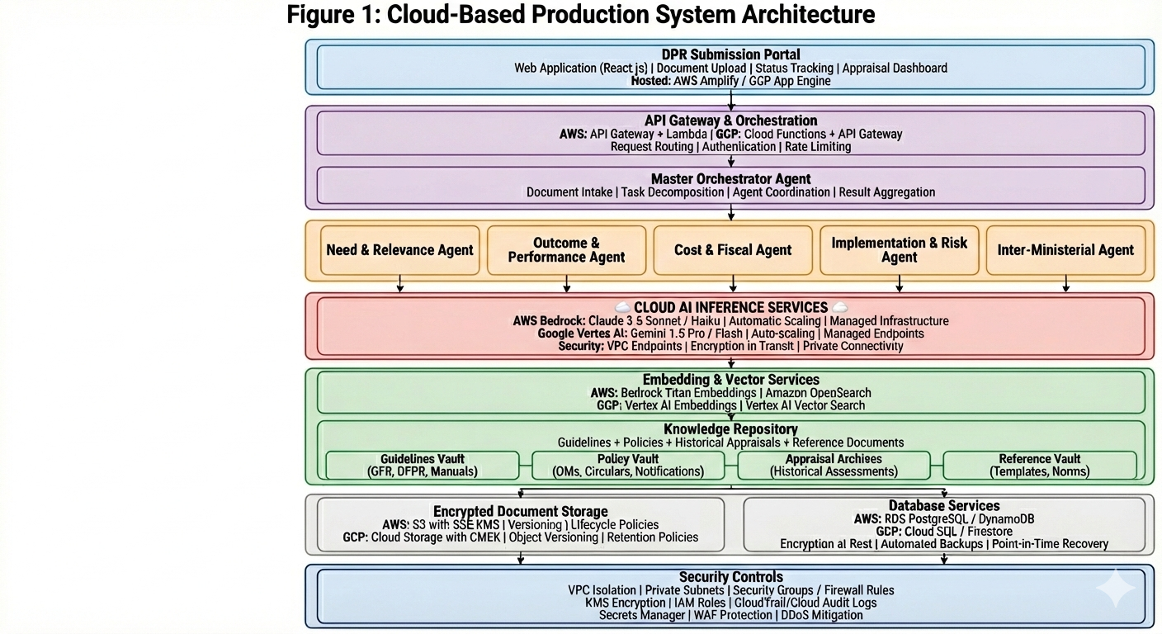

3.3 Multi-Agent Processing Workflow

Figure 5: DPR Processing Workflow with Specialized Agents.
Phase 1: Secure Document Ingestion
HTTPS upload → Virus scan → Format validation → Metadata extraction → Encrypted storage
↓
Phase 2: Document Parsing & Chunking
OCR (if needed) → Text extraction → Intelligent chunking → Embedding generation → Vector index
↓
Phase 3: Master Orchestrator Planning
Task decomposition → Agent assignment → Dependency analysis → Parallel execution plan
↓
Phase 4: Parallel Multi-Agent Analysis
5 specialized agents execute concurrently | RAG-augmented assessment | Cross-referencing guidelines
↓
Phase 5: Result Synthesis & Validation
Orchestrator aggregates findings → Consistency checks → Conflict resolution → Confidence scoring
↓
Phase 6: Report Generation
Structured appraisal note → Risk matrix → Compliance checklist → Recommendation summary
↓
Phase 7: Human Review & Approval
SO reviews AI assessment → Edits/overrides → Final approval → Audit trail

3.4 Agent Specializations (Indicative)
Agent | Assessment Focus
Need & Relevance Agent | Problem justification, duplication check, FC-cycle alignment, strategic fit
Outcome & Performance Agent | Output indicators, outcome measurement, past performance analysis, KPI validation
Cost & Fiscal Agent | Cost norm compliance, affordability check, FC ceiling validation, 5.5x rule assessment
Implementation & Risk Agent | Delivery mechanism feasibility, DBT/PFMS integration, capacity assessment, risk mitigation
Inter-Ministerial Agent | Overlap detection, NITI Aayog coordination, inter-ministerial funding analysis, alignment check

3.5 Technical Components and Services

3.5.1 AWS-Based Implementation
Component | AWS Service
Foundation Models | Amazon Bedrock: Claude 3.5 Sonnet (comprehensive analysis), Claude 3.7 Haiku (quick queries)
Embedding Service | Amazon Bedrock: Titan Embeddings V2 (1024 dimensions)
Vector Database | Amazon OpenSearch Service with k-NN plugin or Aurora PostgreSQL with pgvector extension
Compute | AWS Lambda (serverless agent execution), ECS Fargate (containerized orchestrator)
API Layer | Amazon API Gateway (REST/WebSocket), Application Load Balancer
Storage | Amazon S3 (encrypted document storage), Amazon EFS (shared file system)
Database | Amazon RDS PostgreSQL (metadata), Amazon DynamoDB (session state)
Networking | VPC with private subnets, VPC endpoints, PrivateLink for Bedrock
Security | AWS KMS (encryption), IAM (access control), Secrets Manager, AWS WAF
Monitoring | CloudWatch (metrics/logs), CloudTrail (audit), X-Ray (tracing), GuardDuty (threats)

3.5.2 Google Cloud-Based Implementation
Component | Google Cloud Service
Foundation Models | Vertex AI: Gemini 1.5 Pro (comprehensive analysis), Gemini 1.5 Flash (quick queries)
Embedding Service | Vertex AI Text Embeddings API (768 dimensions)
Vector Database | Vertex AI Vector Search or Cloud SQL for PostgreSQL with pgvector
Compute | Cloud Functions (serverless agents), Cloud Run (containerized orchestrator)
API Layer | Cloud Endpoints (API management), Cloud Load Balancing
Storage | Cloud Storage (encrypted documents), Filestore (shared file system)
Database | Cloud SQL PostgreSQL (metadata), Firestore (session state)
Networking | VPC with private subnets, Private Service Connect, VPC Service Controls
Security | Cloud KMS (CMEK), IAM (access control), Secret Manager, Cloud Armor
Monitoring | Cloud Monitoring, Cloud Logging, Cloud Trace, Security Command Center

4. Deployment Architecture and Scalability

4.1 High-Availability Design
Component | HA Strategy
Frontend | Multi-AZ deployment, CloudFront/Cloud CDN, auto-scaling, health checks
API/Compute | Lambda/Cloud Functions (inherent HA), ECS/Cloud Run multi-AZ, auto-scaling policies
AI Services | Bedrock/Vertex AI fully managed with SLA, automatic failover, regional redundancy
Storage | S3/Cloud Storage (11 nines durability), cross-AZ replication, versioning enabled

4.2 Scalability Model
The cloud-native architecture automatically scales based on demand:
Load Level | Concurrent DPRs | Auto-Scaling Response
Low (Normal) | 1-5 | Minimum instances, baseline AI quota
Medium (Busy) | 6-20 | Horizontal scaling +50%, increased AI throughput
High (Peak) | 20+ | Maximum scaling, priority request queuing, burst AI quota

5. Conclusion
The proposed two-phase automation approach provides the Department of Expenditure with a pragmatic pathway to enhance appraisal efficiency while maintaining appropriate security controls.

